**f. 1r**

Ih*esu* c*rist*

**f. 1v**

dalyid]

**f. 2r**



n*ota*

¶

no*ta*

xx ȝere]

**f. 2v**

Ih*esu* c*rist*

**f. 3r**

hale

n*ota*

**f. 3v**

of lyn

¶

**f. 4r**

no*ta*

¶

**f. 4v**

n*ota*

Ih*esu* C*rist* -------

**f. 5r**

[ca*pitulum*2m

**f. 5v**

n*ota*

no*ta*

**f. 6r**

m*er*ce

ca*pitulum* 3*m*

n*ota*

**f. 6v**

n*ota*

¶

**f. 7r**

mokyd•

¶

**f. 7v**

ca*pitulum* 4m•

no*ta* vayn/

glory /

**f. 8r**

n*ota*

¶

**f. 8v**

R

dyspare]

ca*pitulum* 5m•

**f. 9r**

[no*ta* .;.

n*ota*

.;.

¶

¶

no*ta*

¶

**f. 9v**

M of P/

[ca*pitulum* •6•

**f. 10r**

[ca*pitulum* •7•

**f. 10v**

n*ota*

¶

¶ca*pitulum* •8•

**f. 11r**

¶ca*pitulum* •9•

md

[the flesshely

[lust in †

n*ota*

O

O

¶

Ih*es*u c*rist* helpe

me ;

**f. 11v**

vane

¶ca*pitulum* •10•

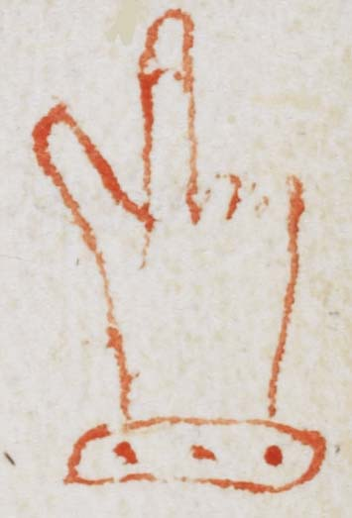

**f. 12r**

¶ca*pitulum* •11•

**f. 12v**

un to hym

**f. 13r**

grace

n*ota*

¶ca*pitulum* •12•

no*ta* dyscrescio*n*

monke

**f. 13v**

• no*ta* •

**f. 14r**

n*ota*

ca*pitulum* •13•

**f. 14v**

^

than •

R Medlay

was wo*n*t so to say

**f. 15r**

¶ca*pitulum* 14

---------suffer deth^

loue

¶

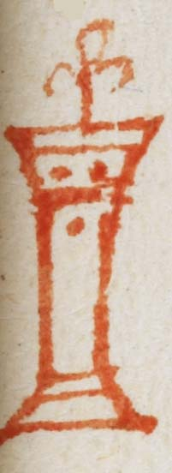

**f. 15v**

meykly &

pacie*n*tly

[hevy*n*

no*ta*

